Wireshark Lab: DHCP

In this lab, we’ll take a quick look at DHCP. DHCP is covered in Section 4.4.2 of the 4th edition of the textbook. Recall that DHCP is used extensively in corporate, university and home-network wired and wireless LANs to dynamically assign IP addresses to hosts (as well as to configure other network configuration information).

This lab is brief, as we’ll only examine the DHCP packets captured by a host. If you also have administrative access to your DHCP server, you may want to repeat this lab after making some configuration changes (such as the lease time). If you have a router at home, you most likely can configure your DHCP server. Because many linux/Unix machines (especially those that serve many users) have a static IP address and because manipulating DHCP on such machines typically requires super-user privileges, we’ll only present a Windows version of this lab below.

DHCP Experiment

In order to observe DHCP in action, we’ll perform several DHCP-related commands and capture the DHCP messages exchanged as a result of executing these commands. Do the following1:

- Begin by opening the Windows Command Prompt application (which can be found in your Accessories folder). As shown in Figure 1, enter
“ipconfig /release”. The executable for ipconfig is in C:\windows\system32. This command releases your current IP address, so that your host’s IP address becomes 0.0.0.0.
- Start up the Wireshark packet sniffer, as described in the introductory Wireshark lab and begin Wireshark packet capture.
- Now go back to the Windows Command Prompt and enter “ipconfig /renew”. This instructs your host to obtain a network configuration, including a new IP address. In Figure 1, the host obtains the IP address 192.168.1.108
- Wait until the “ipconfig /renew” has terminated. Then enter the same command “ipconfig /renew” again.
- When the second “ipconfig /renew” terminates, enter the command “ipconfig/release” to release the previously-allocated IP address to your computer.
- Finally, enter “ipconfig /renew” to again be allocated an IP address for your computer.
- Stop Wireshark packet capture.

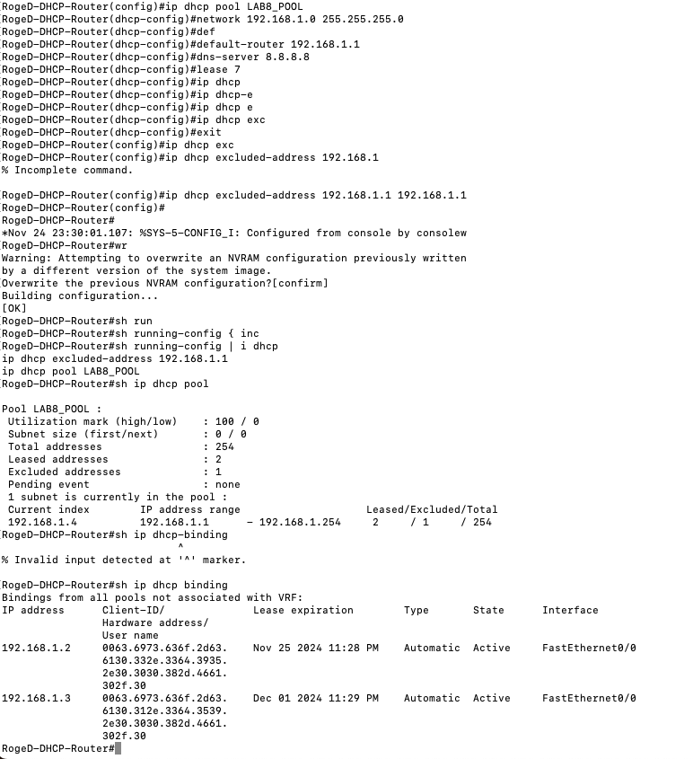

Figure 1 Command Prompt window showing sequence of ipconfig commands that you should enter.

Now let’s take a look at the resulting Wireshark window. To see only the DHCP packets, enter into the filter field “bootp”. (DHCP derives from an older protocol called BOOTP. Both BOOTP and DHCP use the same port numbers, 67 and 68. To see DHCP packets in the current version of Wireshark, you need to enter “bootp” and not “dhcp” in the filter.) We see from Figure 2 that the first ipconfig renew command caused four DHCP packets to be generated: a DHCP Discover packet, a DHCP Offer packet, a DHCP Request packet, and a DHCP ACK packet.

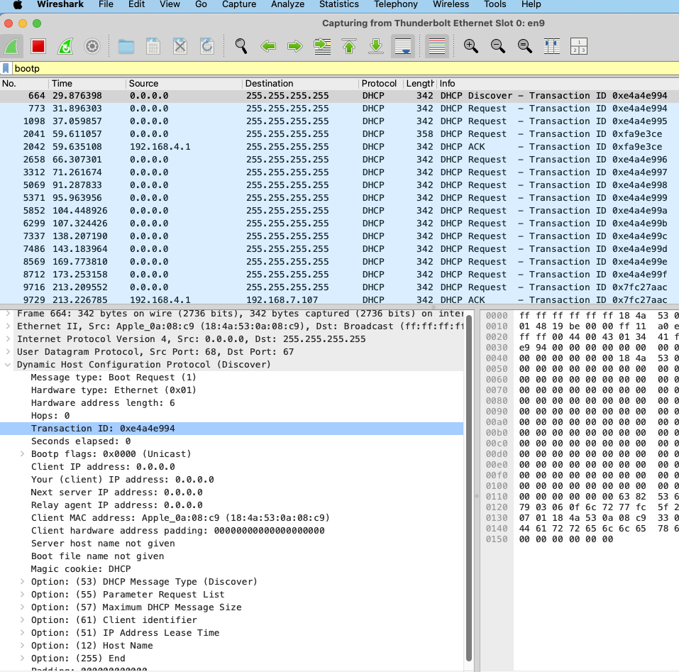

Figure 2 Wireshark window with first DHCP packet – the DHCP Discover packet – expanded.
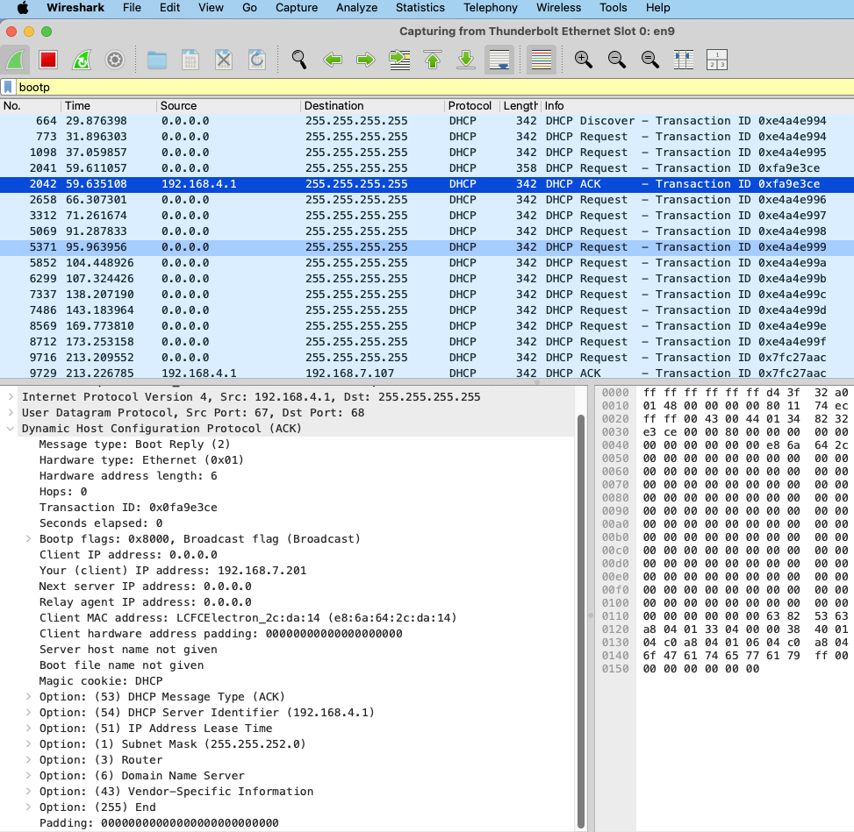

What to Hand In:

You should hand in a screen shot of the Command Prompt window similar to Figure 1 above. Whenever possible, when answering a question below, you should hand in a printout of the packet(s) within the trace that you used to answer the question asked.
Annotate the printout to explain your answer.

Answer the following questions:

- Are DHCP messages sent over UDP or TCP?
  - UDP
- Draw a timing datagram illustrating the sequence of the first four-packet Discover/Offer/Request/ACK DHCP exchange between the client and server. For each packet, indicated the source and destination port numbers. Are the port numbers the same as in the example given in this lab assignment?

- What is the link-layer (e.g., Ethernet) address of your host?
  - Ca:01:3d:59:00:08
- What values in the DHCP discover message differentiate this message from the DHCP request message?
  - The request message has the DHCP Server Identifier, Option 50 with the Requested IP address and the lease information.
- What is the value of the Transaction-ID in each of the first four (Discover/Offer/Request/ACK) DHCP messages? What are the values of the Transaction-ID in the second set (Request/ACK) set of DHCP messages? What is the purpose of the Transaction-ID field?
  - 0x00000eb2
  - To track the DHCP address allocation
- A host uses DHCP to obtain an IP address, among other things. But a host’s IP address is not confirmed until the end of the four-message exchange! If the IP address is not set until the end of the four-message exchange, then what values are used in the IP datagrams in the four-message exchange? For each of the four DHCP messages (Discover/Offer/Request/ACK DHCP), indicate the source and destination IP addresses that are carried in the encapsulating IP datagram.
  - Broadcast
- What is the IP address of your DHCP server?
  - 192.168.1.1
- What IP address is the DHCP server offering to your host in the DHCP Offer message? Indicate which DHCP message contains the offered DHCP address.
  - Requested IP address 192.168.1.4
- In the example screenshot in this assignment, there is no relay agent between the host and the DHCP server. What values in the trace indicate the absence of a relay agent? Is there a relay agent in your experiment? If so what is the IP address of the agent?
  - There are not ttl reductions or gateways traversed.
  - No. If I were to set a DHCP relay it would be at the interface between the DHCP server and the client if there were one.
- Explain the purpose of the router and subnet mask lines in the DHCP offer message.
  - The router acts as the gateway and the DHCP server. The subnet mask places the interface and the client on the same network.
- In the example screenshots in this assignment, the host requests the offered IP address in the DHCP Request message. What happens in your own experiment?
  - The offer and ACK display the offered IP address.
- Explain the purpose of the lease time. How long is the lease time in your experiment?
  - The lease time determines how long the DHCP address is valid for. It actually begins renewing attempts after half of the time has elapsed. Lease time is used for many reasons but primarily to release unused IP addresses back to the DHCP pool for re-use.
- What is the purpose of the DHCP release message? Does the DHCP server issue an acknowledgment of receipt of the client’s DHCP request? What would happen if the client’s DHCP release message is lost?
  - The DHCP release command releases the IP address from being used by the client and returns the address to the DHCP pool.
  - Yes
  - The address would not be released until the reservation timed out.
- Clear the bootp filter from your Wireshark window. Were any ARP packets sent or received during the DHCP packet-exchange period? If so, explain the purpose of those ARP packets.
  - Yes.
  - The ARP packets wanted to know what IP address now lived at the MAC address in the ARP request. This would be used for intra subnet routing.

DHCP using GNS3

Do the Following.
- Select 2 client routers and 1 DHCP router.
- Configure DHCP router with correct configurations.
- Start Wireshark trace between R1 and SW.
- Configure such that F0/0 should take ip address through DHCP.
- Stop Wireshark capture.
- Analyze the Wireshark trace for DHCP packets.

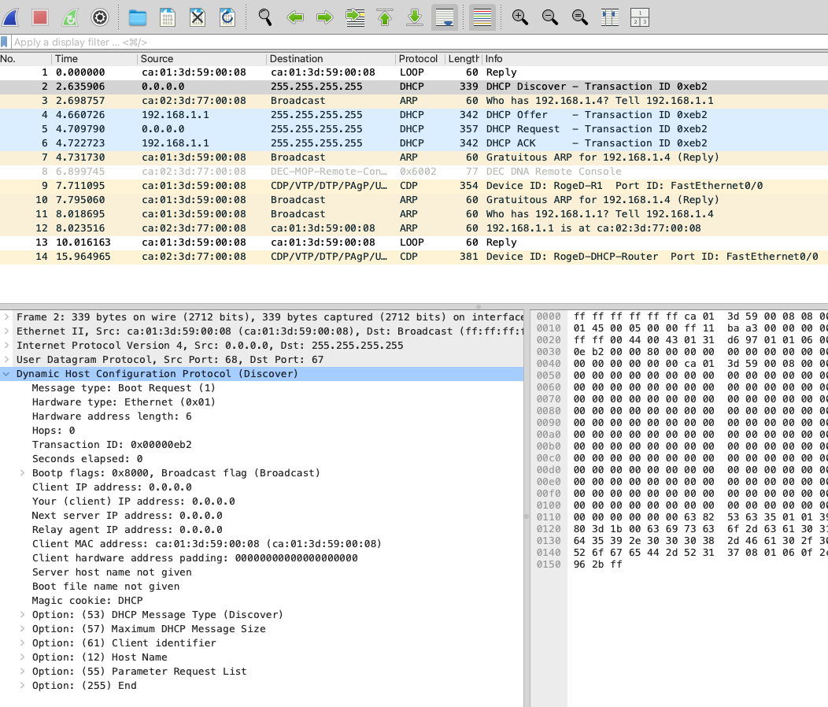

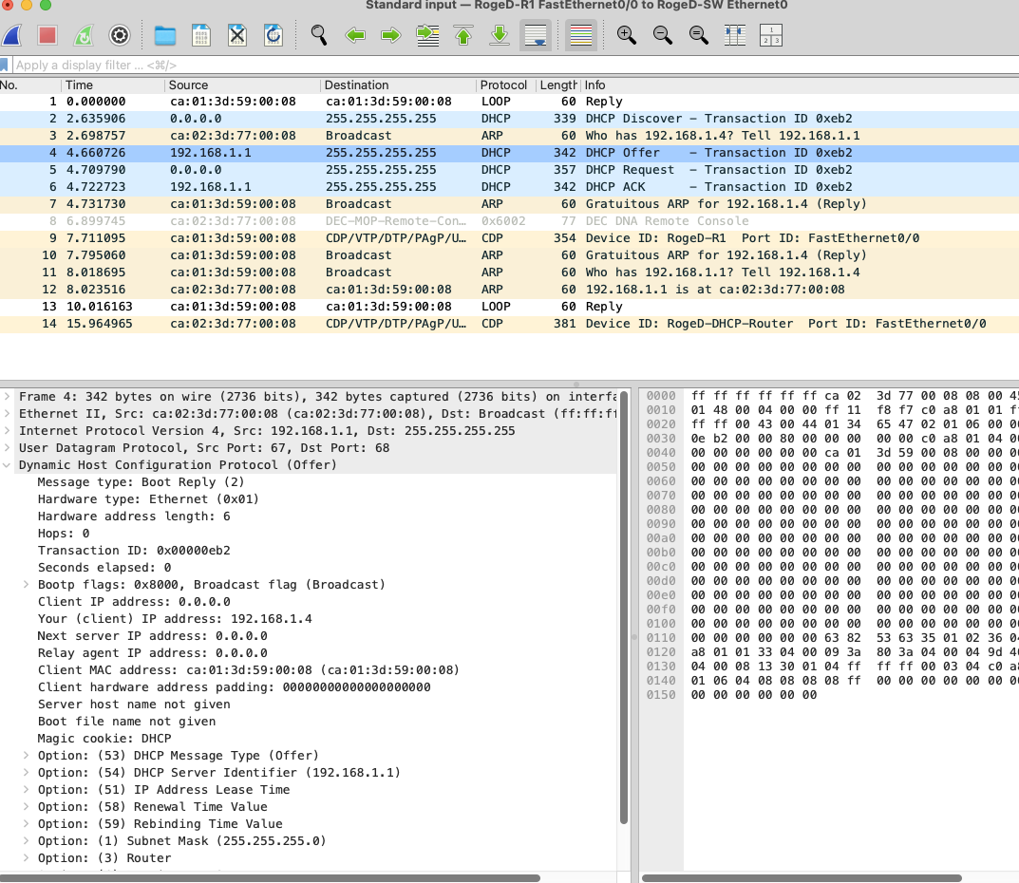

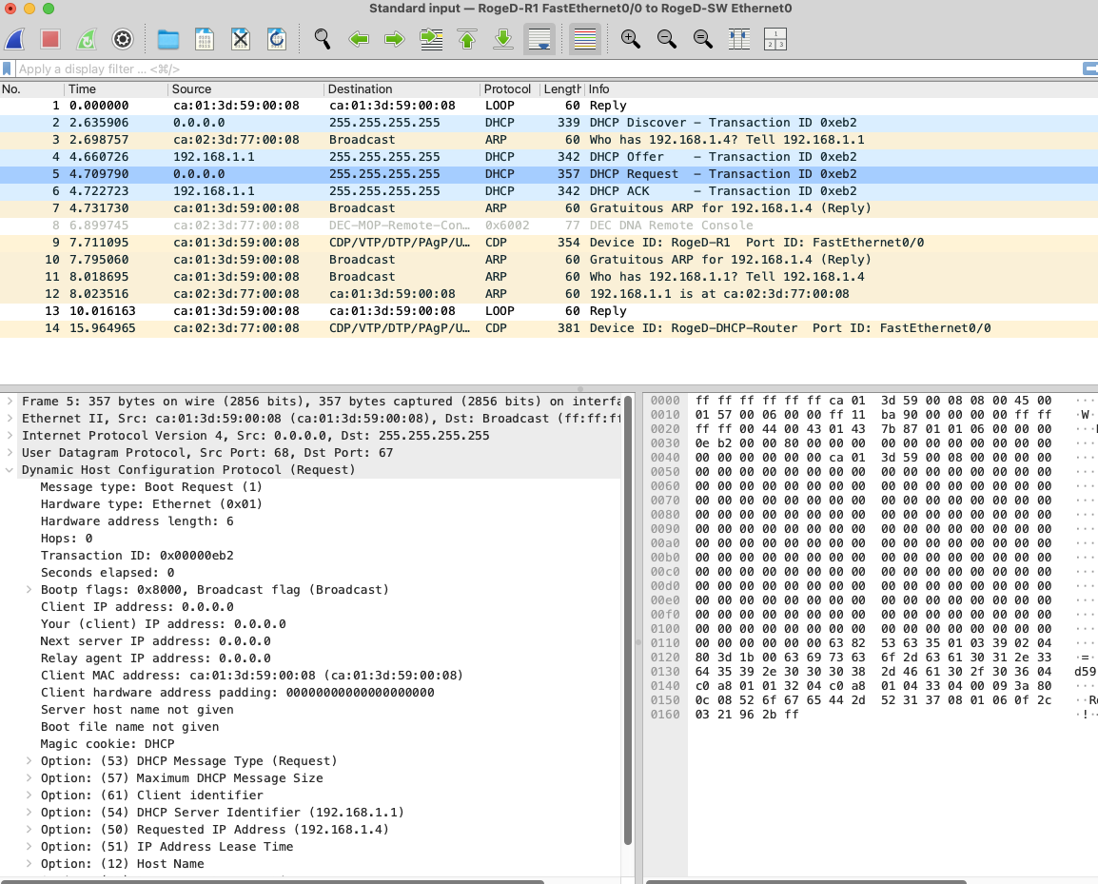

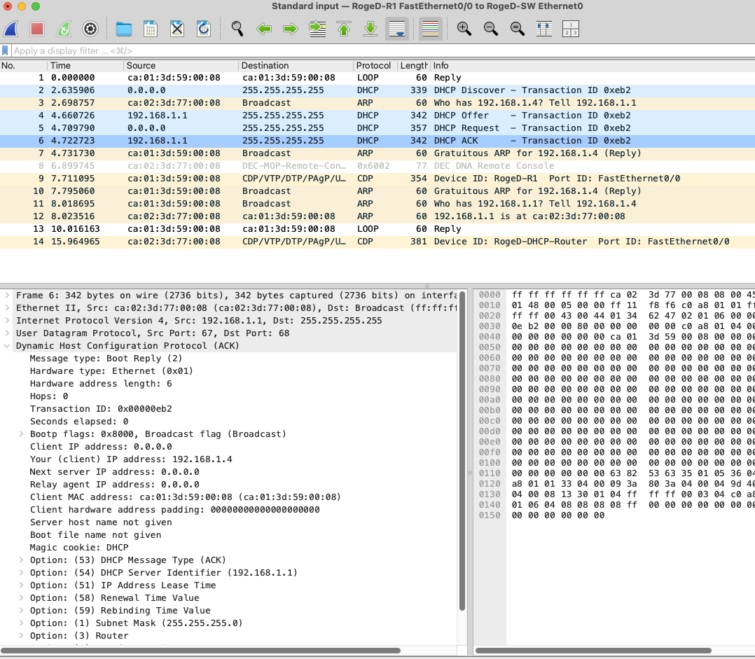

Answer the following questions.

- Are DHCP messages sent over UDP or TCP.
  - UDP
- What is source and destination address for DHCP discover, offer request and acknowledge messages.
  - Discover: Source: 0.0.0.0 | Destination: 255.255.255.255
  - Offer: Source: 192.168.1.1 | Destination: 255.255.255.255
  - Ack: Source: 192.168.1.1 | Destination: 255.255.255.255
- What is Source and Destination Ethernet address for DHCP discover message?
  - Ca:01:3d:59:00:08 | Broadcast: ff:ff:ff:ff:ff:ff
- Provide screenshots as mentioned below.

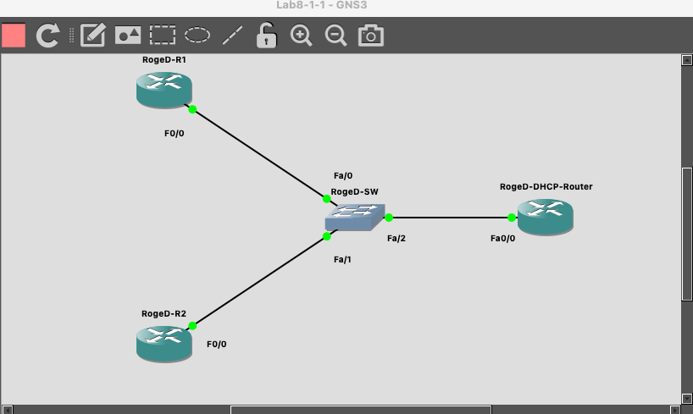

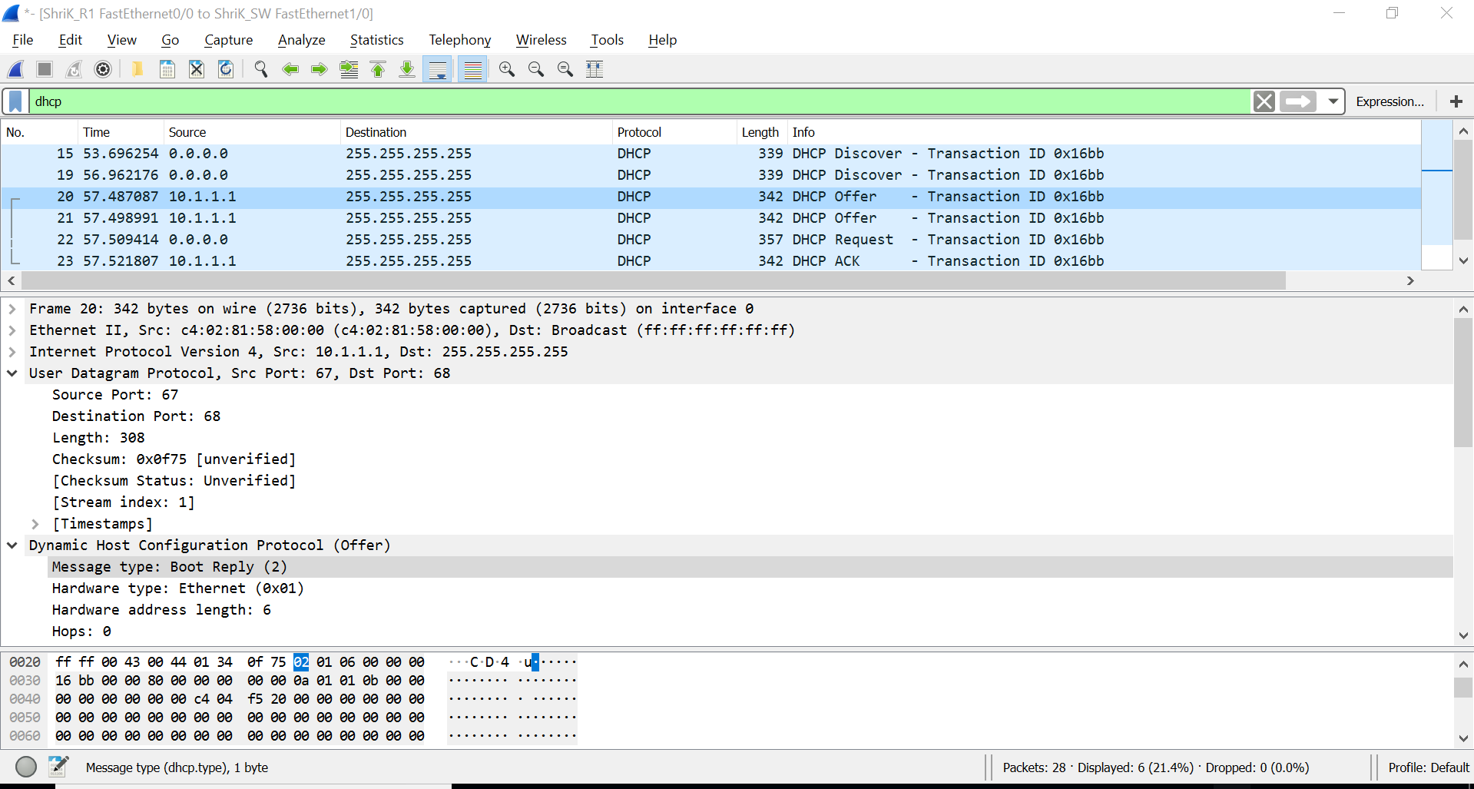

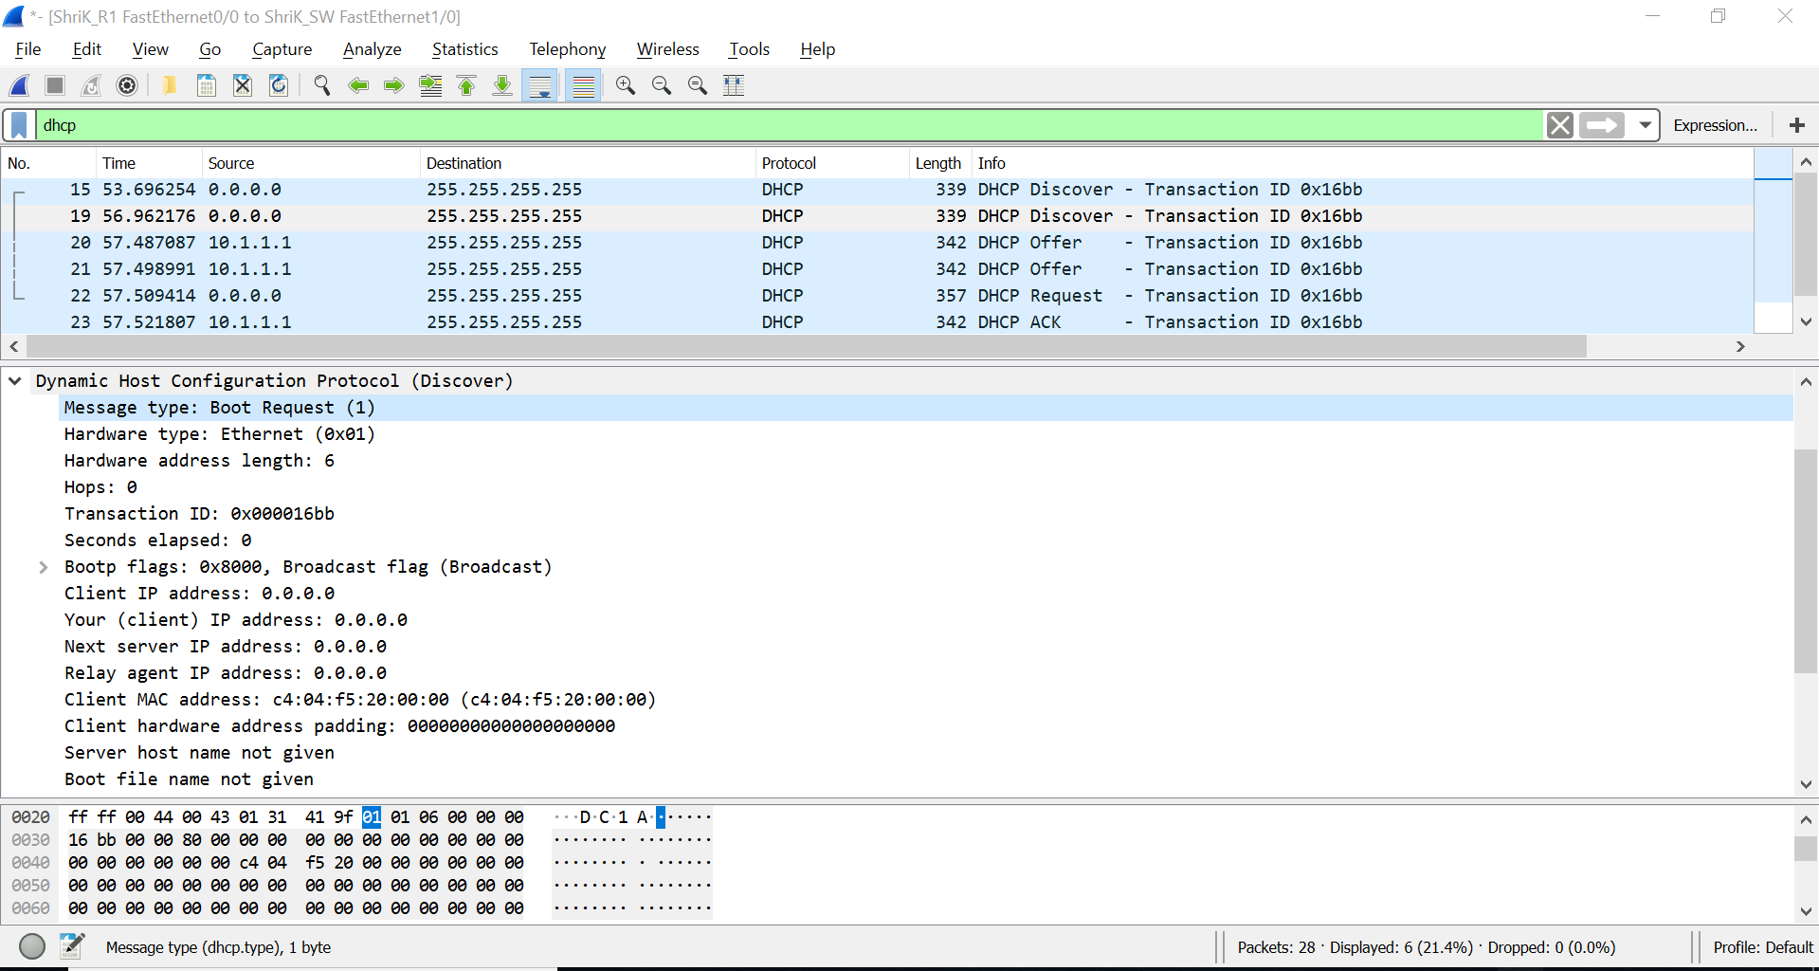

Lab Report
Write a minimum of two type-written pages with a minimum of 12-point font describing what you learned in the lab. Do NOT simply repeat the steps you performed, summarize the purpose of the lab by explaining the concepts covered.

Your lab report will be submitted to turnitn.com. Be sure you write your report in your own words. If you don’t I will know it and you will receive zero points for the lab and face possible other consequences. Although you may work with other to compete the lab procedure, your report MUST be your original work.

This lab demonstrated the process of configuring and deploying DHCP. It also demonstrated the 4 way handshake that consummates the DHCP protocol.

This lab had zero complexity that would be created with vlan or routing boundaries and was designed to clearly illustrate the back and forth process of the discovery, request, offer and ACK.

This exercise made it clear that the process is very mechanized and repeatable. It also demonstrated the speed and repeatability of the process.

DHCP is on of the most utilized processes we use in the connected internet world. Without it our lives would be a static IP hell.

It allows us to over subscribe out networks. It allows us to be very flexible and dynamic with options that may or may not be required for most circumstances.

